Test Case: tc002_SPX_Dev5_Crear_Requisicion_Spot_Con_FAD_Tipo_Cobro_CC
Step 1 - Enter username and password and click to button Enter : Credentials Entered
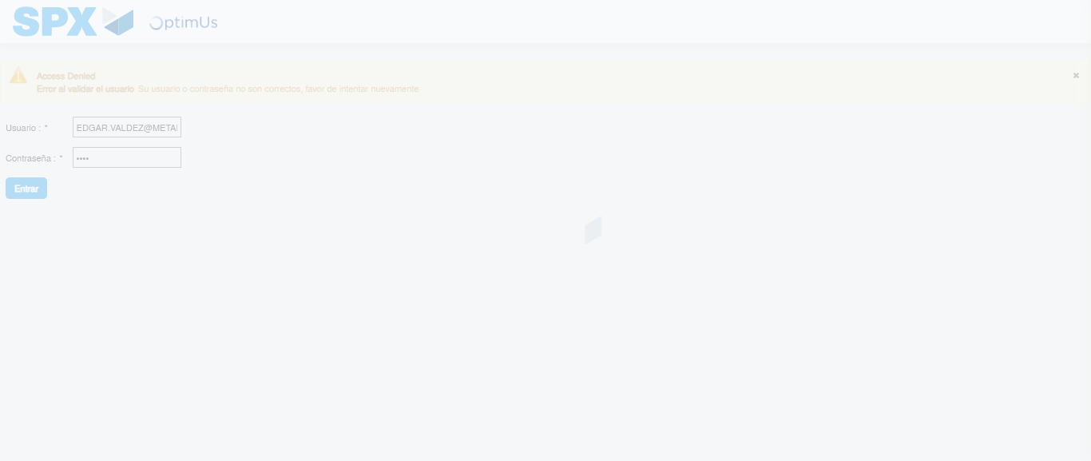Image file-name: QC_Testing-tc002_SPX_Dev5_Crear_Requisicion_Spot_Con_FAD_Tipo_Cobro_CC-1781570900888

Step 2 - Select to UEN and Access to Spot Buy Requisitions : UEN Correctly selected and Correct access
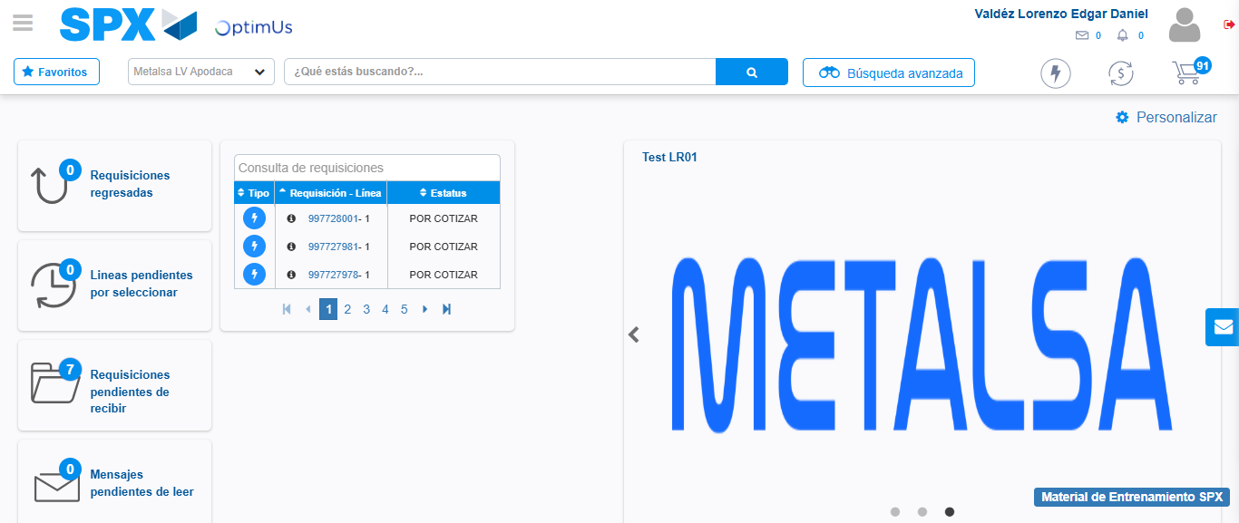Image file-name: QC_Testing-tc002_SPX_Dev5_Crear_Requisicion_Spot_Con_FAD_Tipo_Cobro_CC-1781570927962

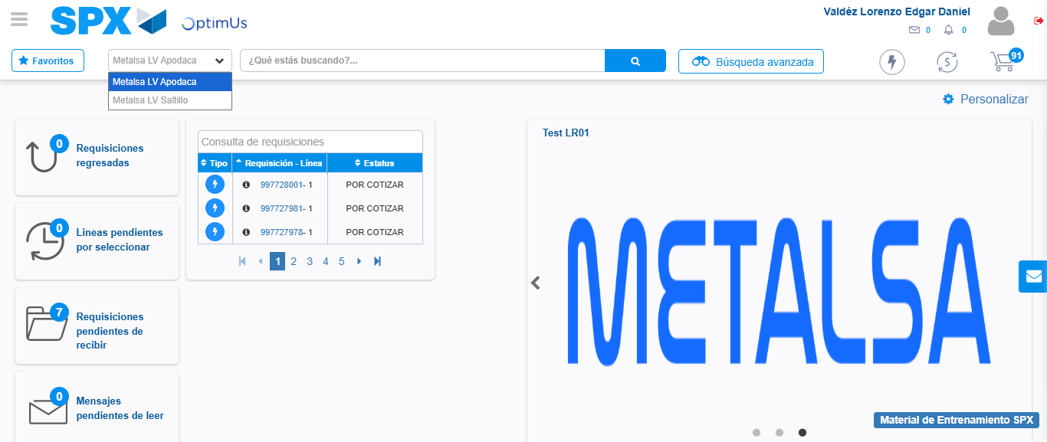Image file-name: QC_Testing-tc002_SPX_Dev5_Crear_Requisicion_Spot_Con_FAD_Tipo_Cobro_CC-1781570930591

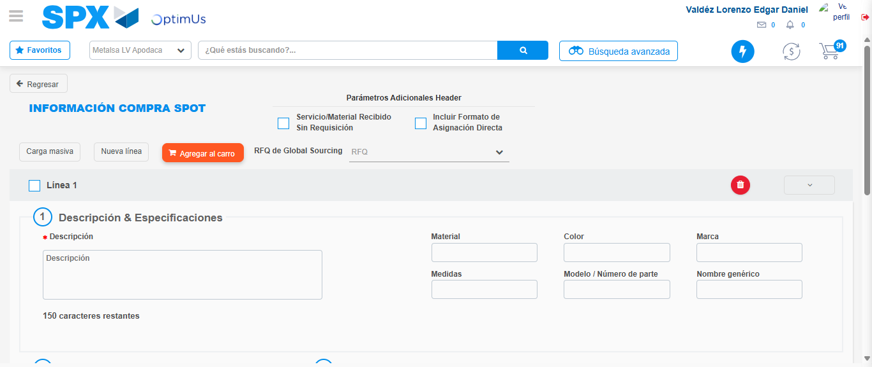Image file-name: QC_Testing-tc002_SPX_Dev5_Crear_Requisicion_Spot_Con_FAD_Tipo_Cobro_CC-1781570967839

Step 3 - Add FAD to Requisition: FAD Successfully Added
Image file-name: QC_Testing-tc002_SPX_Dev5_Crear_Requisicion_Spot_Con_FAD_Tipo_Cobro_CC-1781570968072

Image file-name: QC_Testing-tc002_SPX_Dev5_Crear_Requisicion_Spot_Con_FAD_Tipo_Cobro_CC-1781570968283

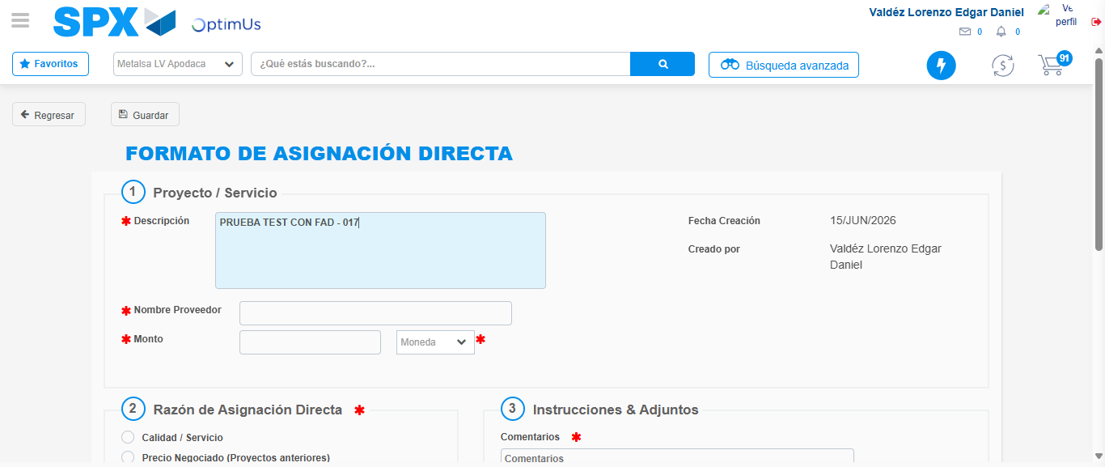Image file-name: QC_Testing-tc002_SPX_Dev5_Crear_Requisicion_Spot_Con_FAD_Tipo_Cobro_CC-1781570970983

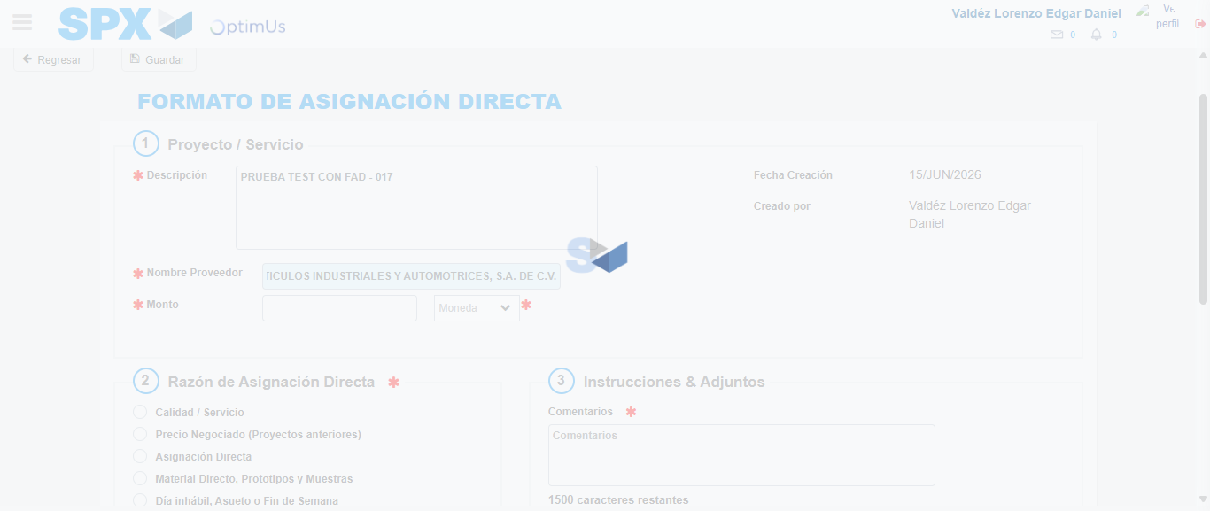Image file-name: QC_Testing-tc002_SPX_Dev5_Crear_Requisicion_Spot_Con_FAD_Tipo_Cobro_CC-1781570978379

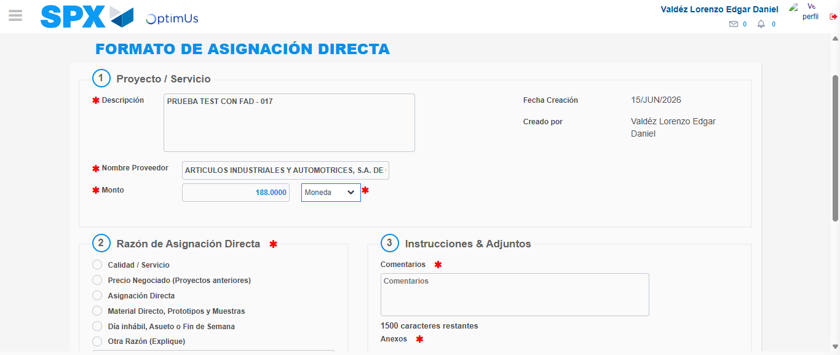Image file-name: QC_Testing-tc002_SPX_Dev5_Crear_Requisicion_Spot_Con_FAD_Tipo_Cobro_CC-1781570979361

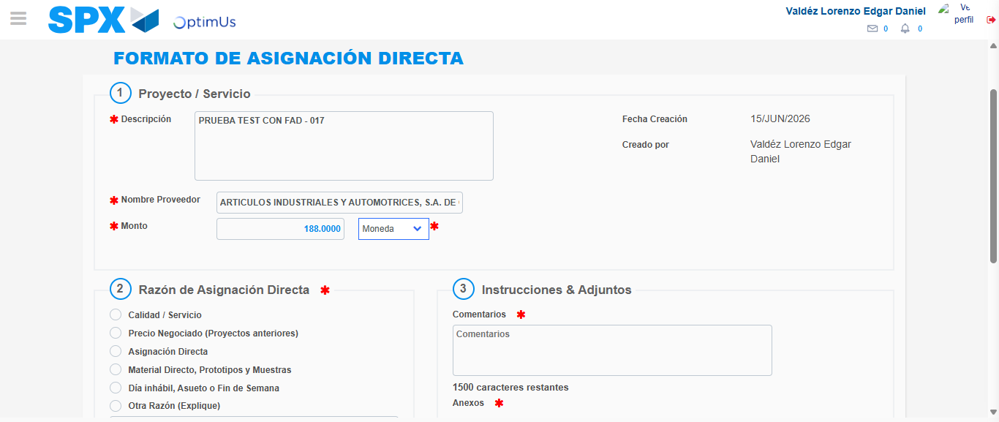Image file-name: QC_Testing-tc002_SPX_Dev5_Crear_Requisicion_Spot_Con_FAD_Tipo_Cobro_CC-1781570979613

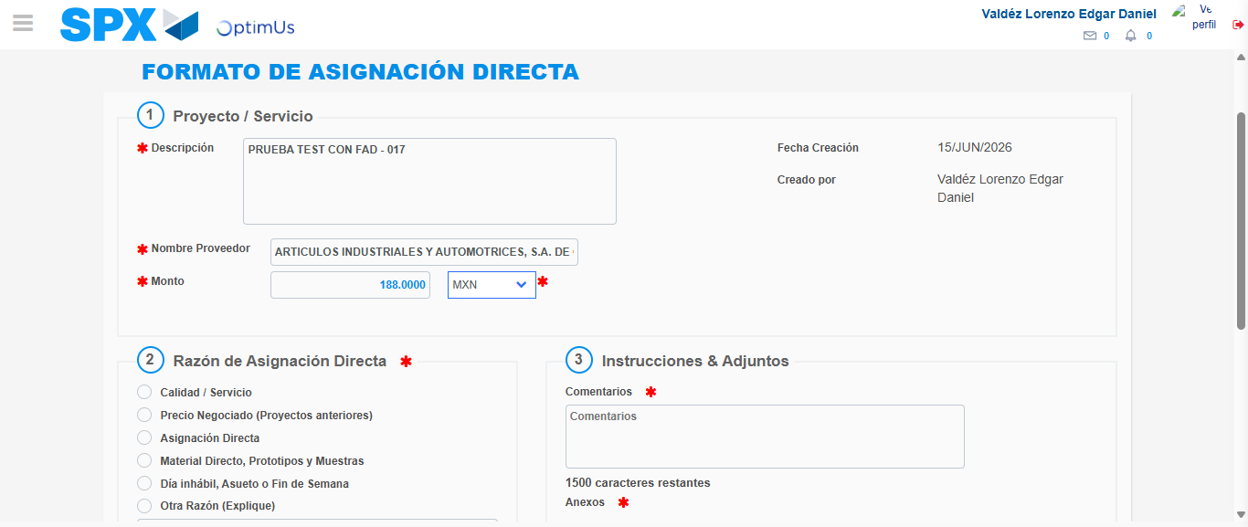Image file-name: QC_Testing-tc002_SPX_Dev5_Crear_Requisicion_Spot_Con_FAD_Tipo_Cobro_CC-1781570980013

Image file-name: QC_Testing-tc002_SPX_Dev5_Crear_Requisicion_Spot_Con_FAD_Tipo_Cobro_CC-1781570980219

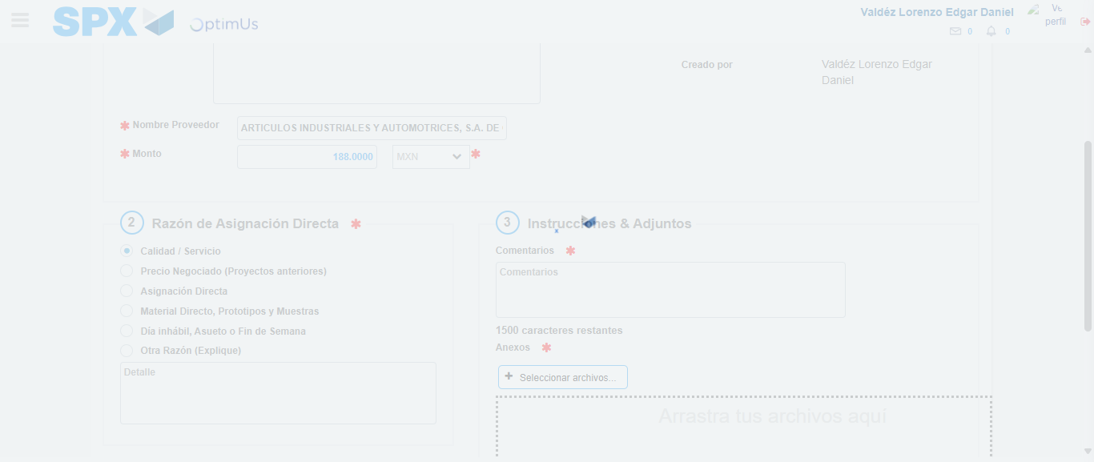Image file-name: QC_Testing-tc002_SPX_Dev5_Crear_Requisicion_Spot_Con_FAD_Tipo_Cobro_CC-1781570981071

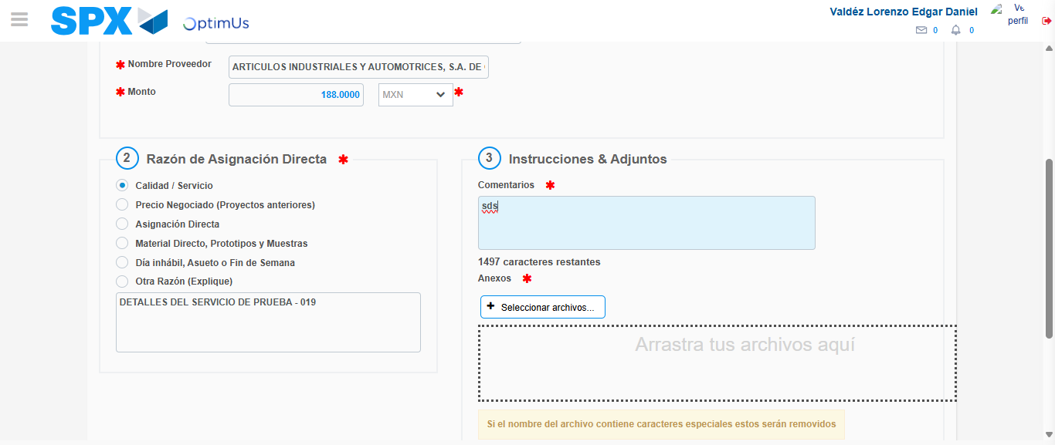Image file-name: QC_Testing-tc002_SPX_Dev5_Crear_Requisicion_Spot_Con_FAD_Tipo_Cobro_CC-1781570992549

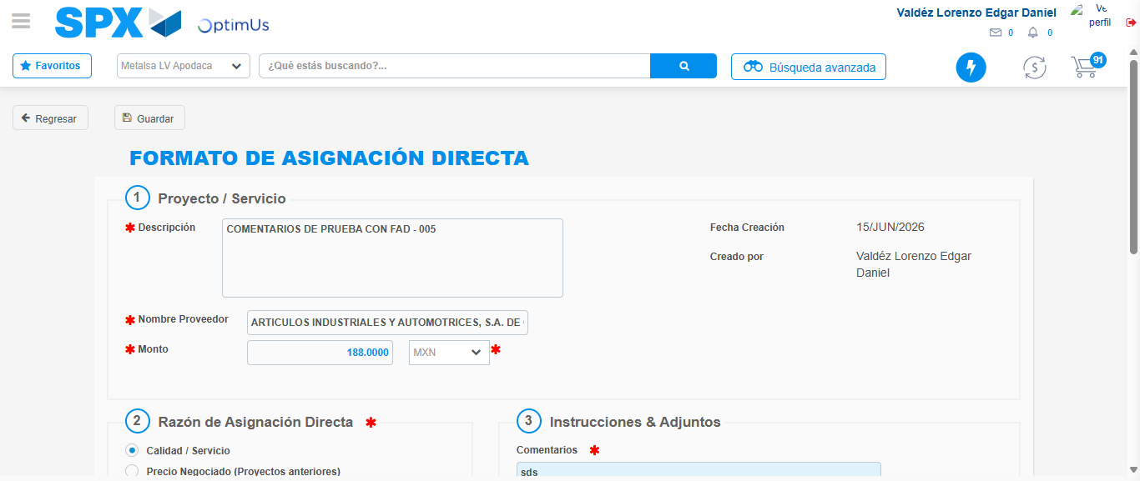Image file-name: QC_Testing-tc002_SPX_Dev5_Crear_Requisicion_Spot_Con_FAD_Tipo_Cobro_CC-1781570993206

Step 4 - Data Capture Spot Buy Requisition: Data captured correctly
Image file-name: QC_Testing-tc002_SPX_Dev5_Crear_Requisicion_Spot_Con_FAD_Tipo_Cobro_CC-1781570968072

Image file-name: QC_Testing-tc002_SPX_Dev5_Crear_Requisicion_Spot_Con_FAD_Tipo_Cobro_CC-1781570968283

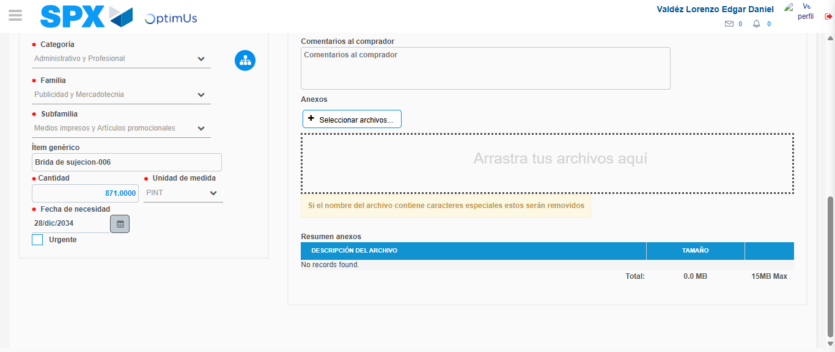Image file-name: QC_Testing-tc002_SPX_Dev5_Crear_Requisicion_Spot_Con_FAD_Tipo_Cobro_CC-1781571005133

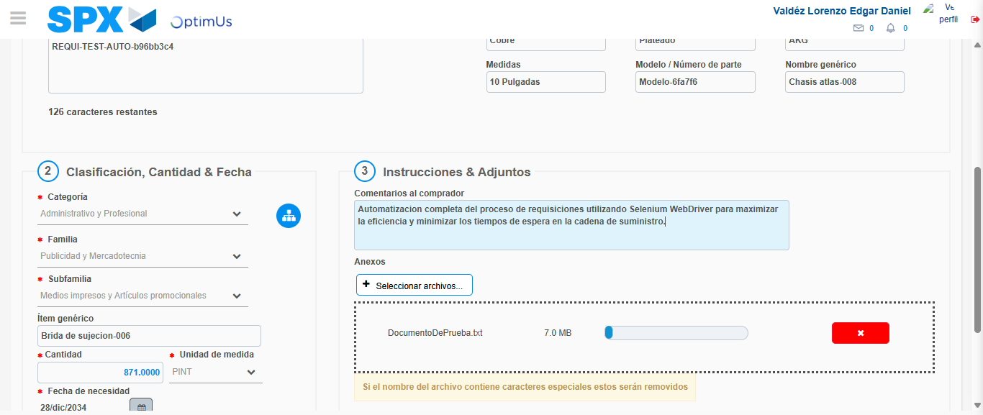Image file-name: QC_Testing-tc002_SPX_Dev5_Crear_Requisicion_Spot_Con_FAD_Tipo_Cobro_CC-1781571005895

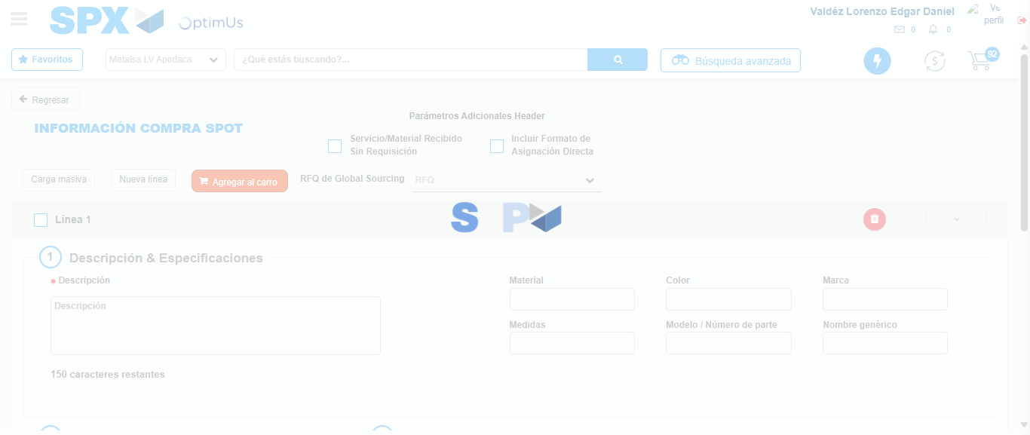Image file-name: QC_Testing-tc002_SPX_Dev5_Crear_Requisicion_Spot_Con_FAD_Tipo_Cobro_CC-1781571012009

Step 5 - Select to Requisition: Requisition Correctly selected
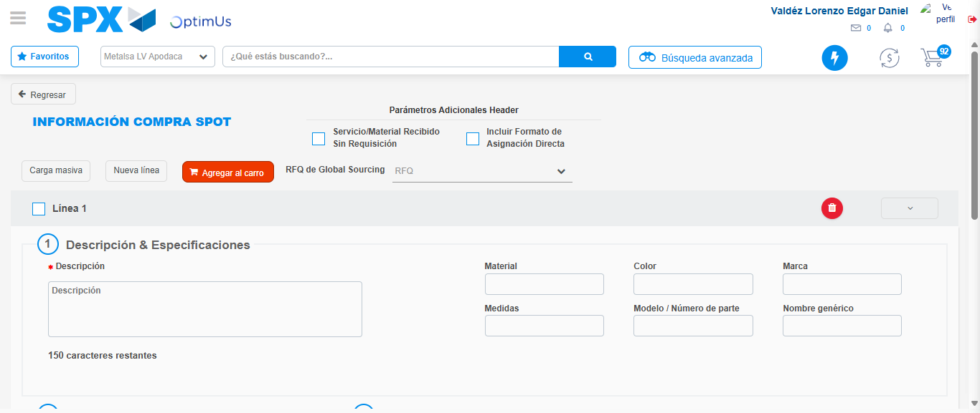Image file-name: QC_Testing-tc002_SPX_Dev5_Crear_Requisicion_Spot_Con_FAD_Tipo_Cobro_CC-1781571012194

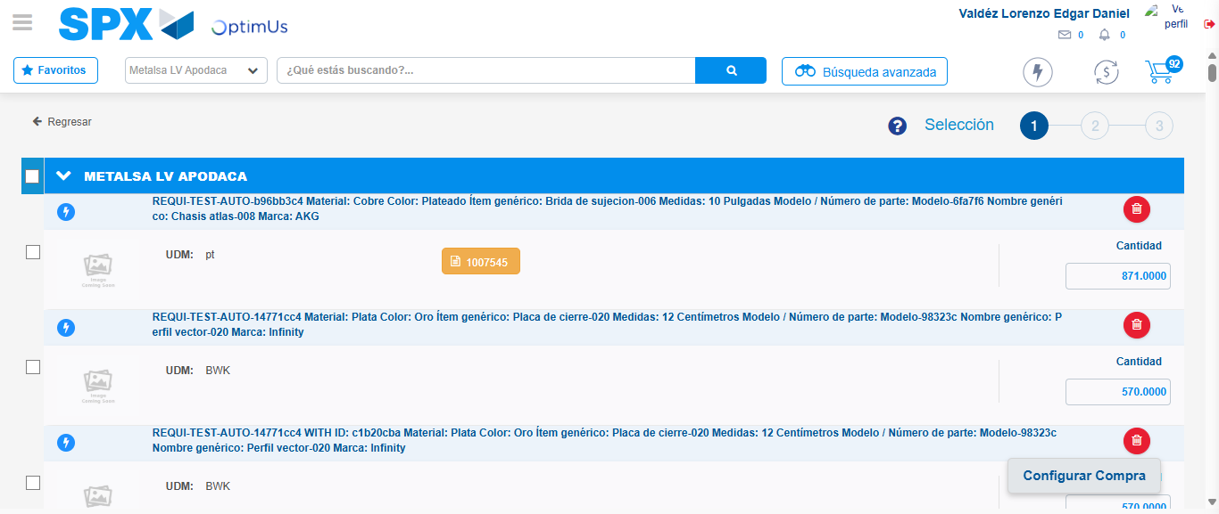Image file-name: QC_Testing-tc002_SPX_Dev5_Crear_Requisicion_Spot_Con_FAD_Tipo_Cobro_CC-1781571020944

Image file-name: QC_Testing-tc002_SPX_Dev5_Crear_Requisicion_Spot_Con_FAD_Tipo_Cobro_CC-1781571021176

Image file-name: QC_Testing-tc002_SPX_Dev5_Crear_Requisicion_Spot_Con_FAD_Tipo_Cobro_CC-1781571021395

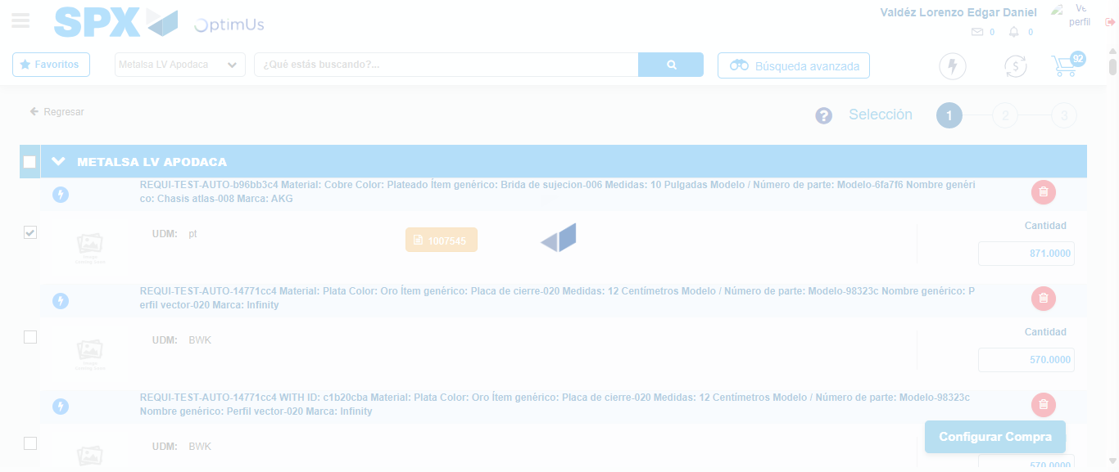Image file-name: QC_Testing-tc002_SPX_Dev5_Crear_Requisicion_Spot_Con_FAD_Tipo_Cobro_CC-1781571022291

Step 6 - Select Type Account For Requisition: Type Account Correctly selected
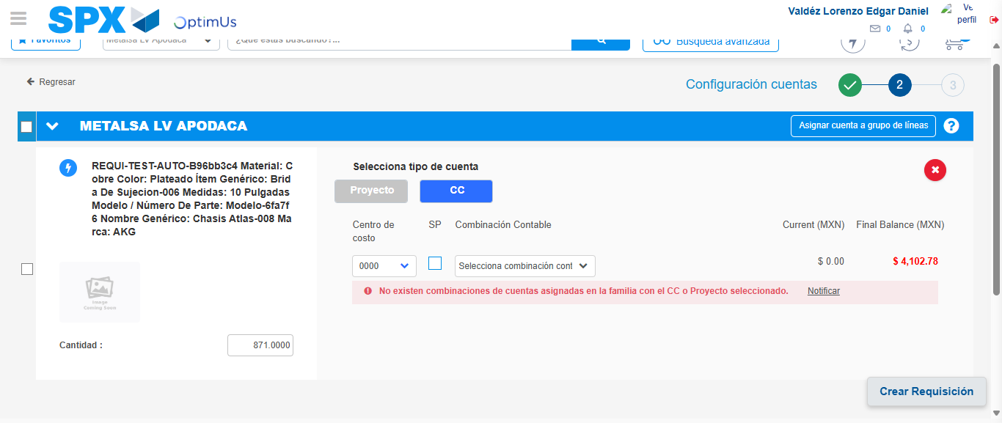Image file-name: QC_Testing-tc002_SPX_Dev5_Crear_Requisicion_Spot_Con_FAD_Tipo_Cobro_CC-1781571045777

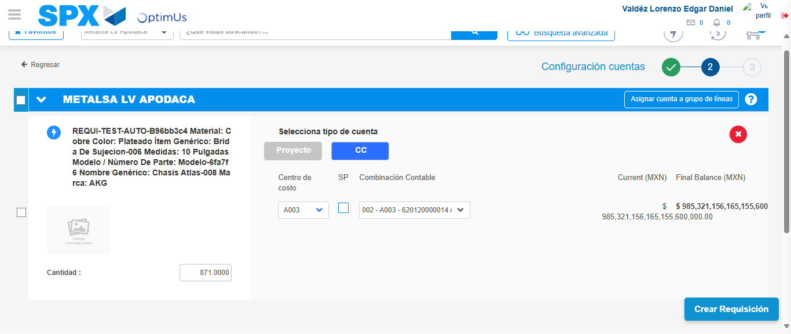Image file-name: QC_Testing-tc002_SPX_Dev5_Crear_Requisicion_Spot_Con_FAD_Tipo_Cobro_CC-1781571054180

Image file-name: QC_Testing-tc002_SPX_Dev5_Crear_Requisicion_Spot_Con_FAD_Tipo_Cobro_CC-1781571054353

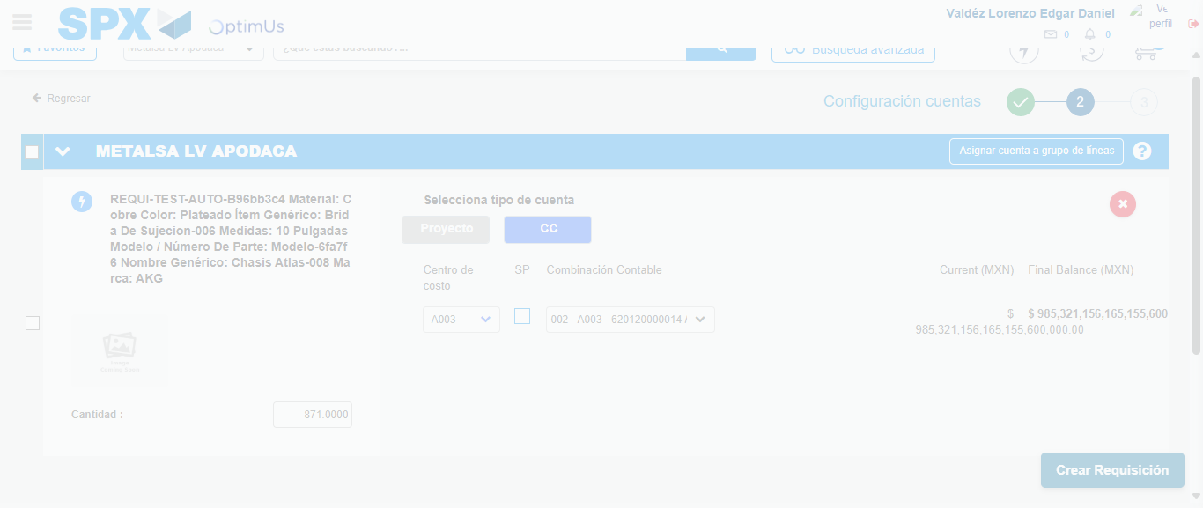Image file-name: QC_Testing-tc002_SPX_Dev5_Crear_Requisicion_Spot_Con_FAD_Tipo_Cobro_CC-1781571054696

Step 7 - Accept to Requisition: Requisition Accepted
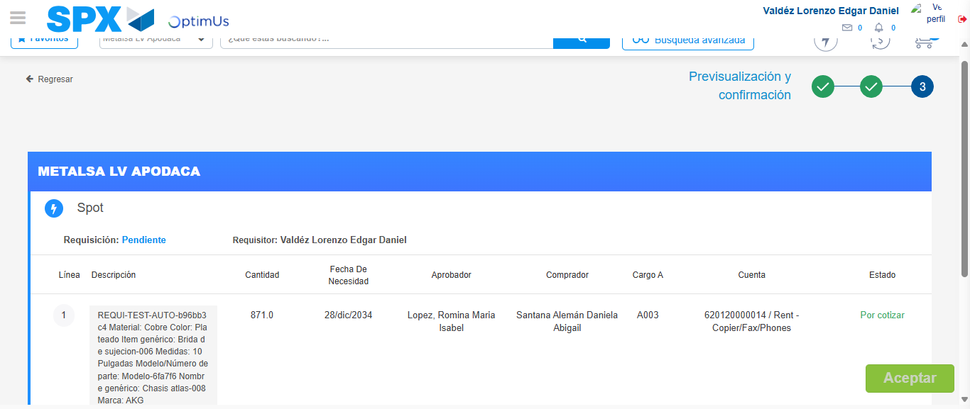Image file-name: QC_Testing-tc002_SPX_Dev5_Crear_Requisicion_Spot_Con_FAD_Tipo_Cobro_CC-1781571055513

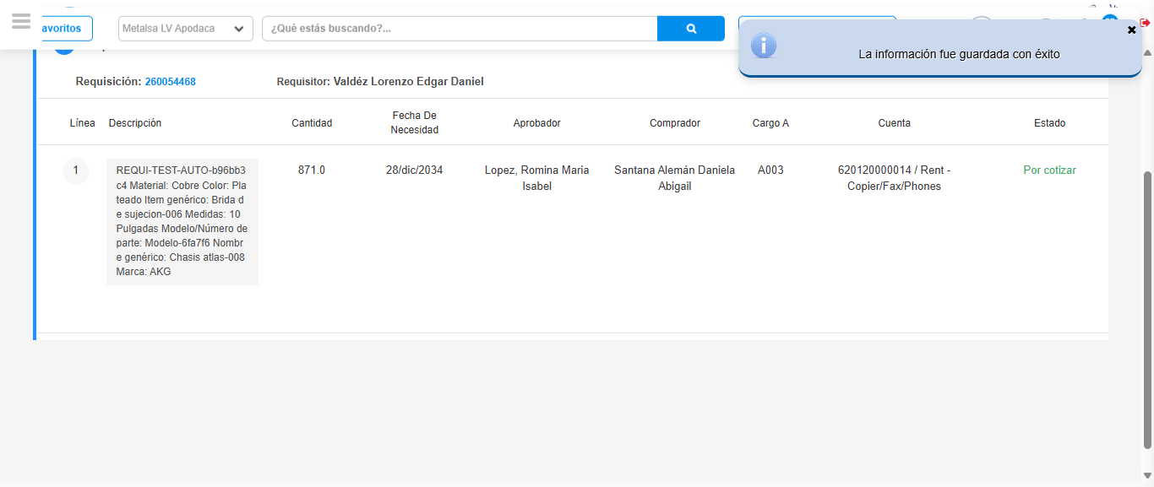Image file-name: QC_Testing-tc002_SPX_Dev5_Crear_Requisicion_Spot_Con_FAD_Tipo_Cobro_CC-1781571057966

Step 8 - Return to Main Page SPX : Return to Main Page SPX
Image file-name: QC_Testing-tc002_SPX_Dev5_Crear_Requisicion_Spot_Con_FAD_Tipo_Cobro_CC-1781570927962

Image file-name: QC_Testing-tc002_SPX_Dev5_Crear_Requisicion_Spot_Con_FAD_Tipo_Cobro_CC-1781570930591

Image file-name: QC_Testing-tc002_SPX_Dev5_Crear_Requisicion_Spot_Con_FAD_Tipo_Cobro_CC-1781570967839

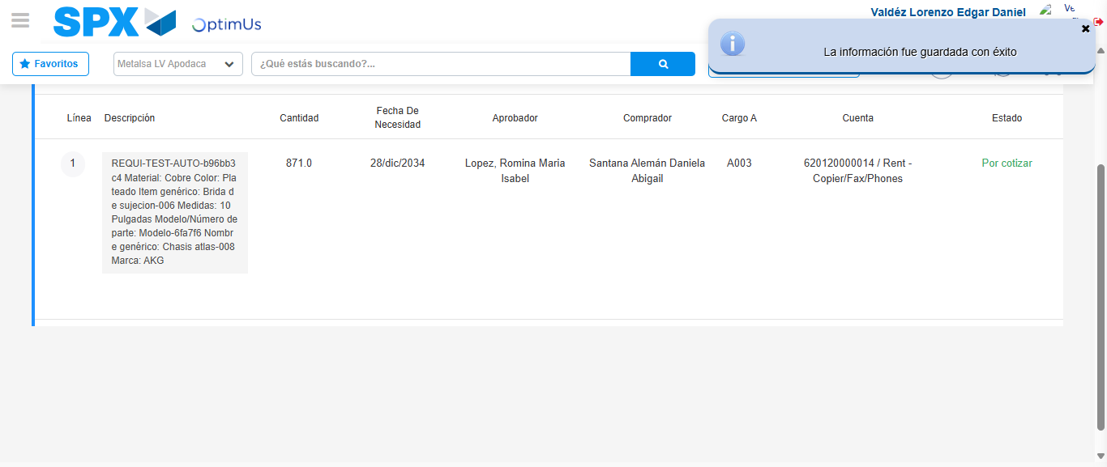Image file-name: QC_Testing-tc002_SPX_Dev5_Crear_Requisicion_Spot_Con_FAD_Tipo_Cobro_CC-1781571060212

Image file-name: QC_Testing-tc002_SPX_Dev5_Crear_Requisicion_Spot_Con_FAD_Tipo_Cobro_CC-1781571060401

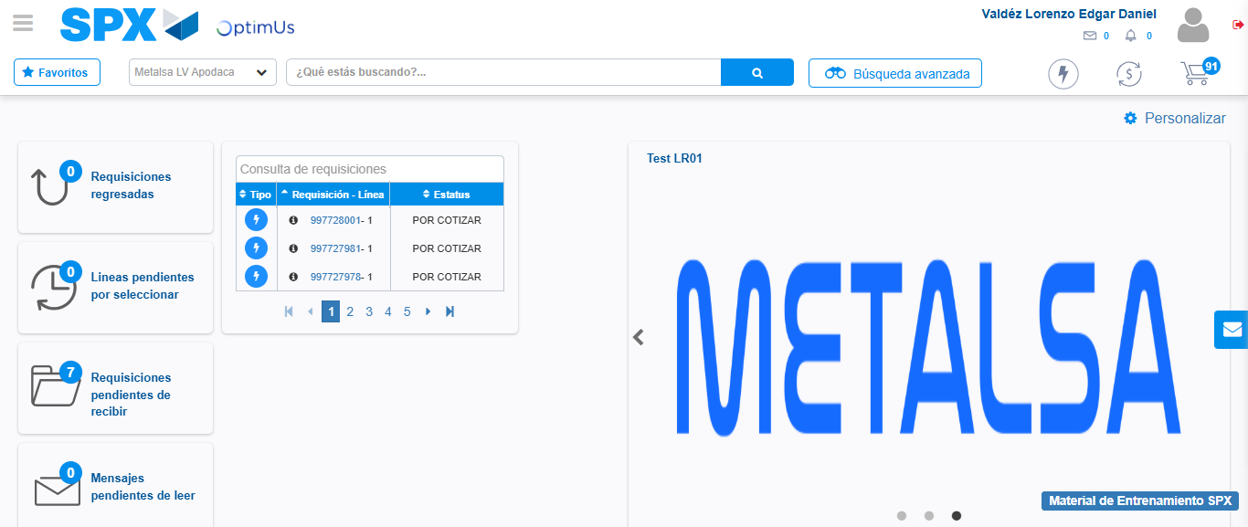Image file-name: QC_Testing-tc002_SPX_Dev5_Crear_Requisicion_Spot_Con_FAD_Tipo_Cobro_CC-1781571081411

Step 9 - Log Out : Log Out SPX
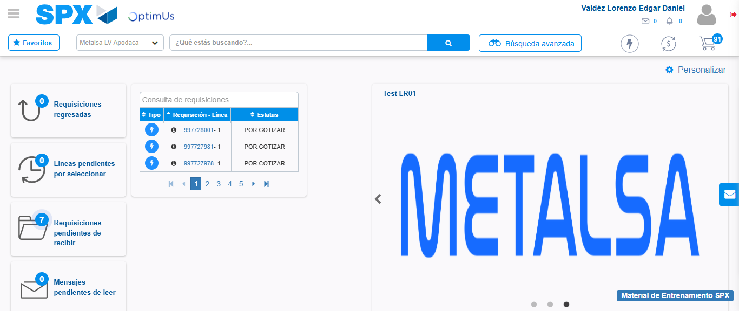Image file-name: QC_Testing-tc002_SPX_Dev5_Crear_Requisicion_Spot_Con_FAD_Tipo_Cobro_CC-1781571081665

